# Installation Guide To Windows 10

## Prerequisites:

### System Requirements:

* Processor: 1 GHz or faster.
* RAM: 1 GB for 32-bit or 2 GB for 64-bit.
* Hard disk space: 16 GB for 32-bit or 20 GB for 64-bit.
* Graphics card: DirectX 9 or later with WDDM 1.0 driver.
* Display: 800 x 600 resolution.

## Backup:

Ensure you have a backup of important files on an external drive or cloud storage.

## Product Key:

Have a valid Windows 10 product key.

### Internet Connection:

A stable internet connection for updates during installation.

# Installation Steps:

Step 1: Prepare Installation Media

## Download Windows 10:

Visit the official Microsoft website and download the Windows 10 ISO file

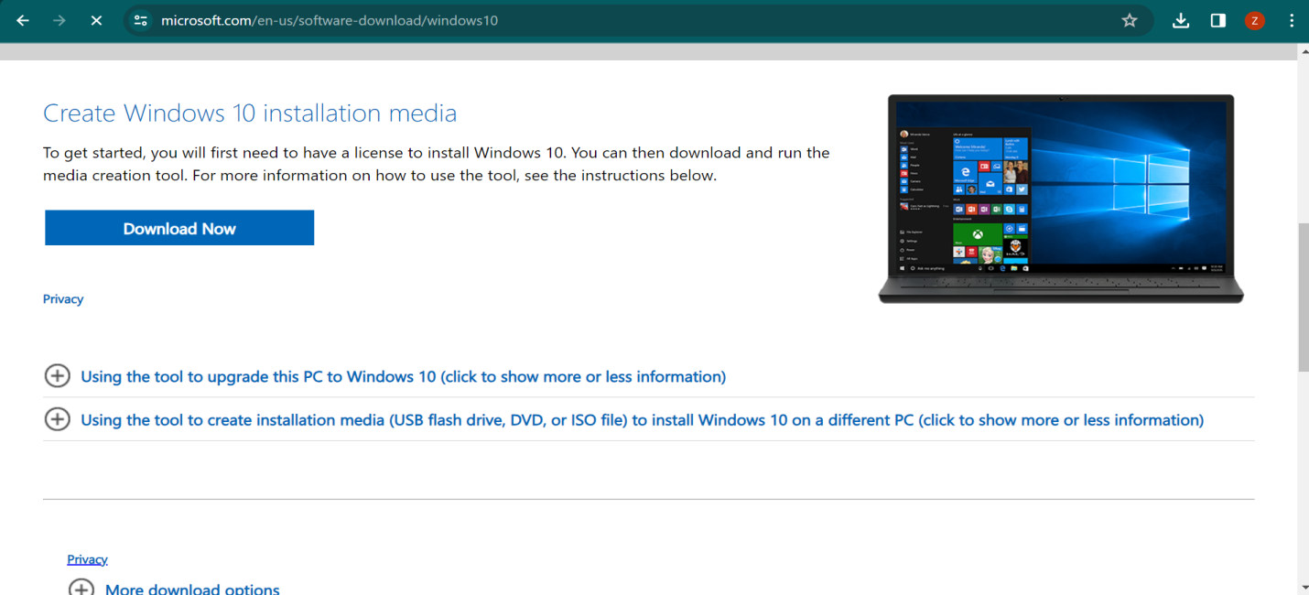

## Download Windows 10 - Google Chrome 1_25_2024 12_04_30 AM.png

## Create Installation Media:

Use the Windows 10 Media Creation Tool to create a bootable USB drive or burn the ISO to a DVD.

**Step 2**: Boot from Installation Media

### Insert Media:

Insert the USB drive or DVD into the computer.

### Access BIOS/UEFI:

Restart the computer and enter the BIOS/UEFI setup by pressing the designated key (usually Del, F12, or Esc).

### Set Boot Order:

Set the boot order to prioritize the USB drive or DVD.

### Save and Exit:

Save changes and exit the BIOS.

**Step 1**: Select Language time and keyboard.

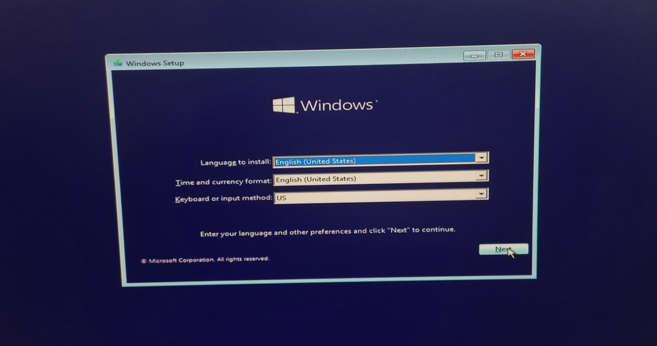

**Step 2**: Begin Installation

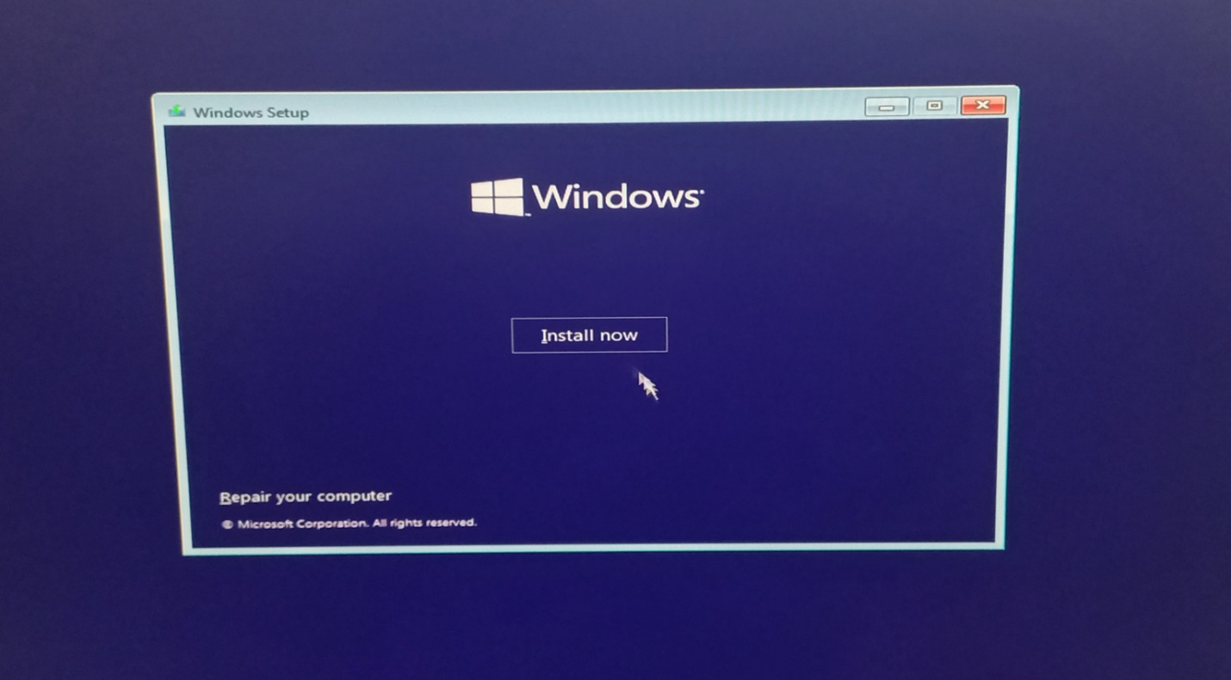

**Step 3**: Enter the Windows 10 product key. If you don’t have product key just click on”I don’t have product key”.

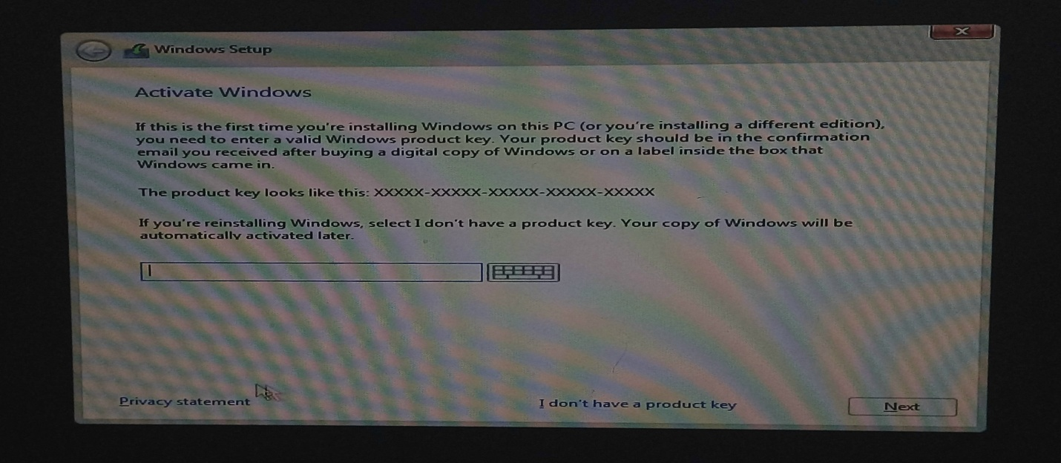

**Step 4**: Select operating system, in our case we will select windows 10 pro.

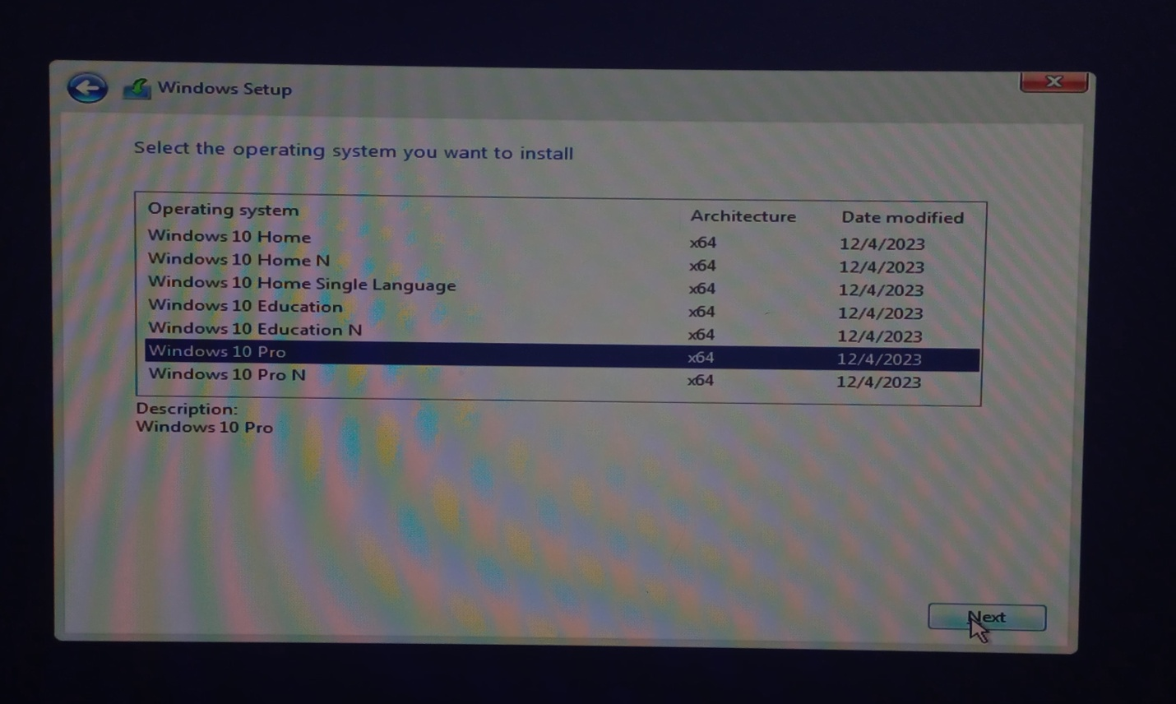

**Step 5**: Agree license terms.

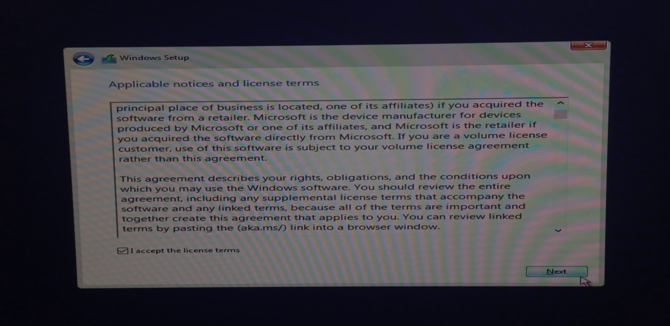

**Step 6**: Choose the partition where you want to install Windows. You may create or delete partitions as needed.

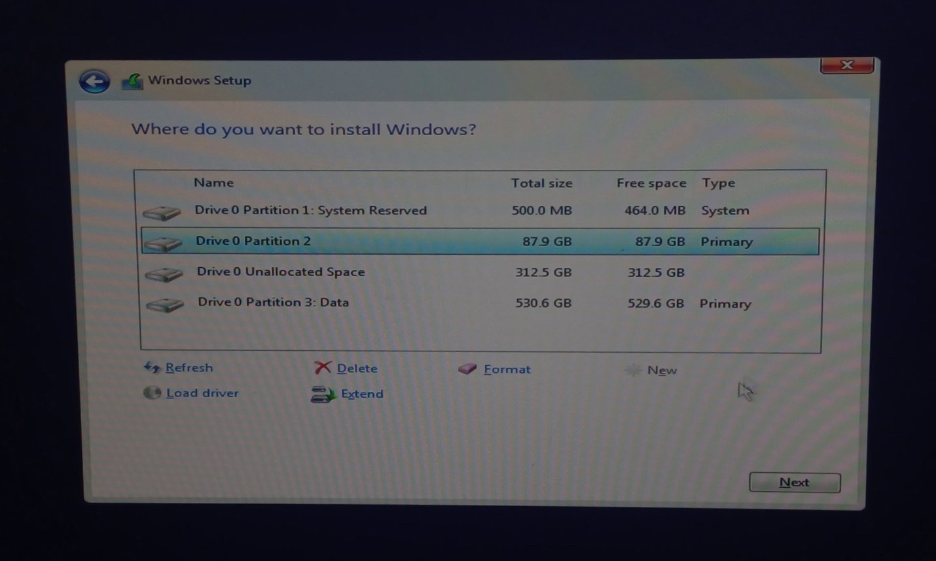

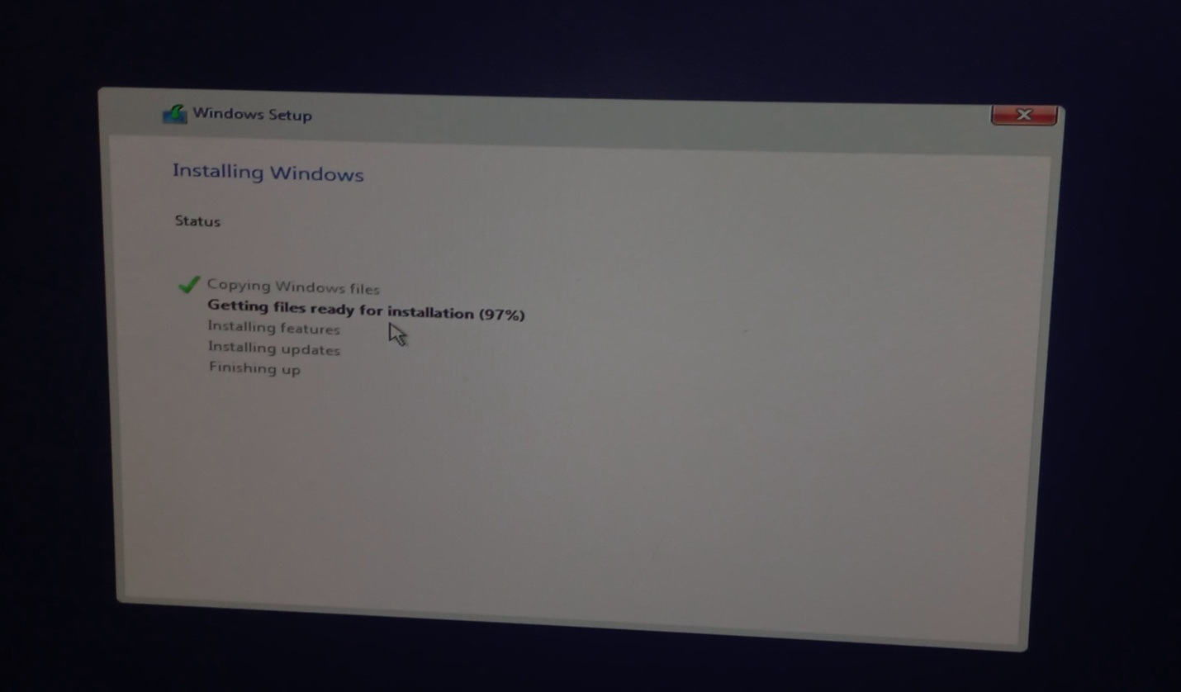

**Step 7**: To boot from usb press any key to continue.

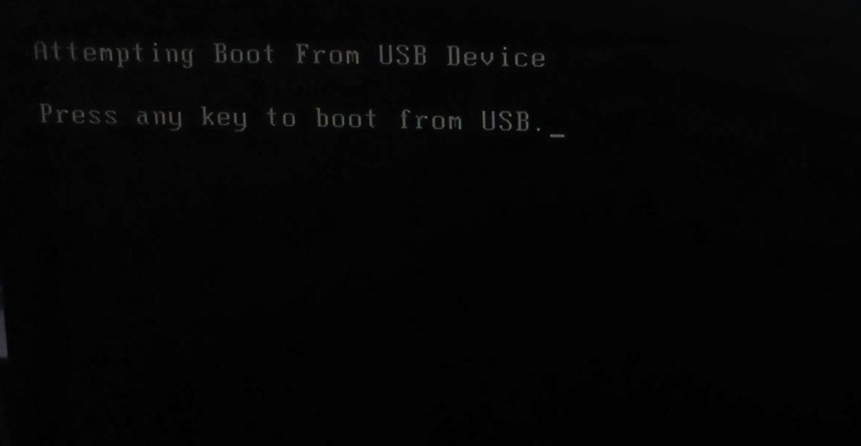

**Step 8**: Select the region.

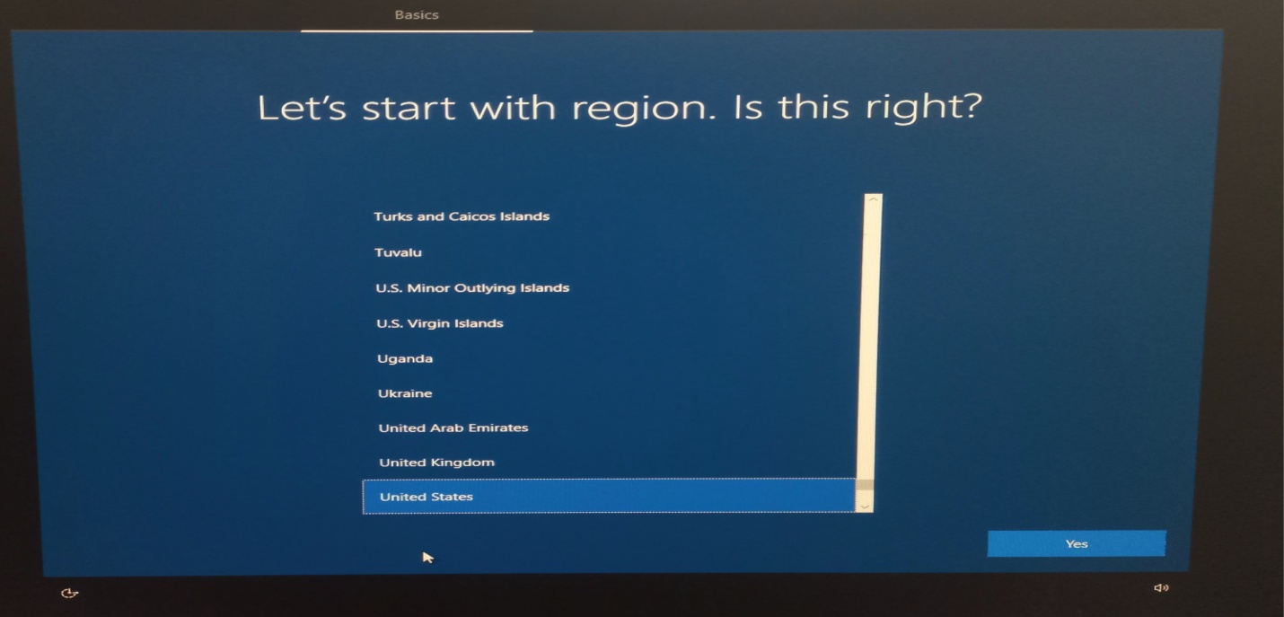

**Step 9**: Select keyboard layout.

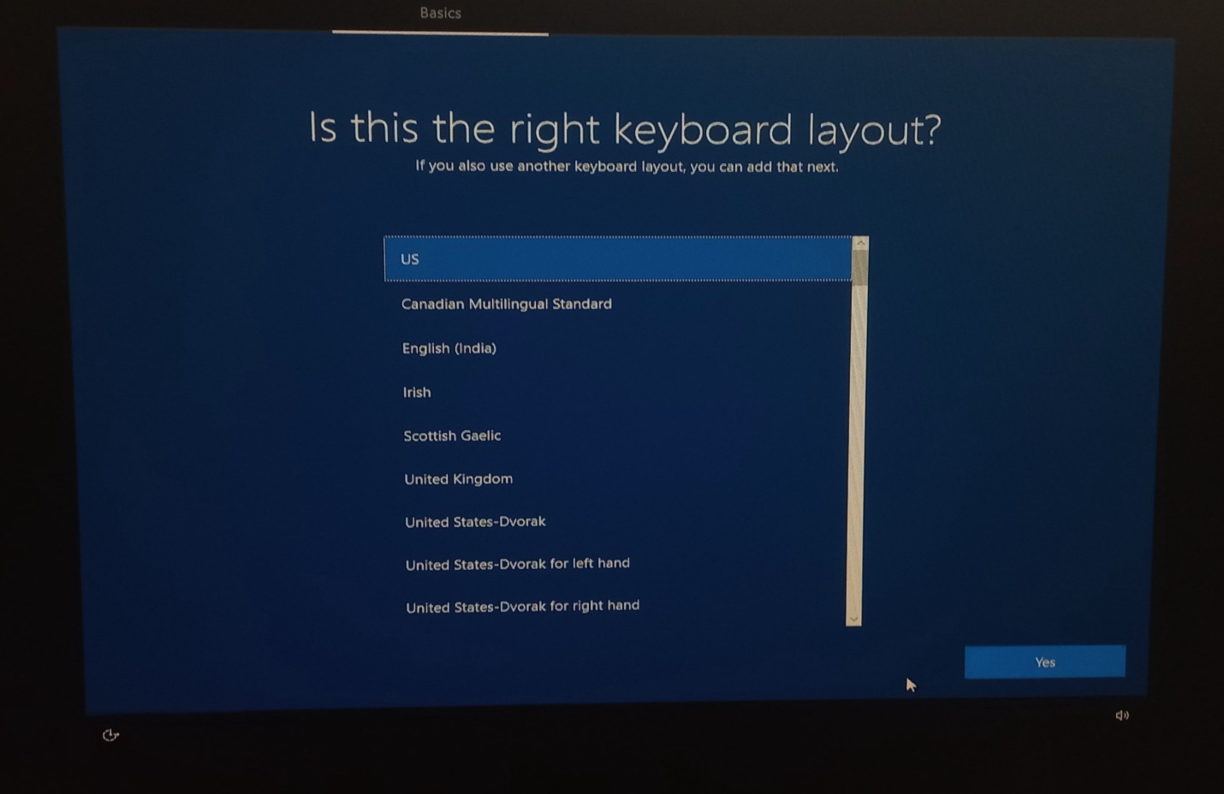

**Step 10**: Select a name for your pc.

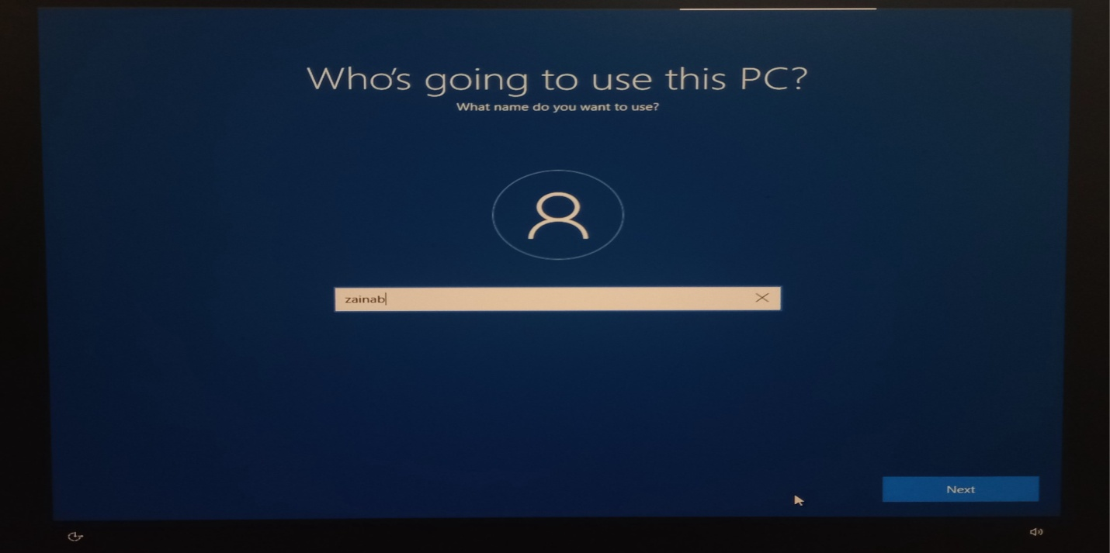

**Step 11**: Create a password.

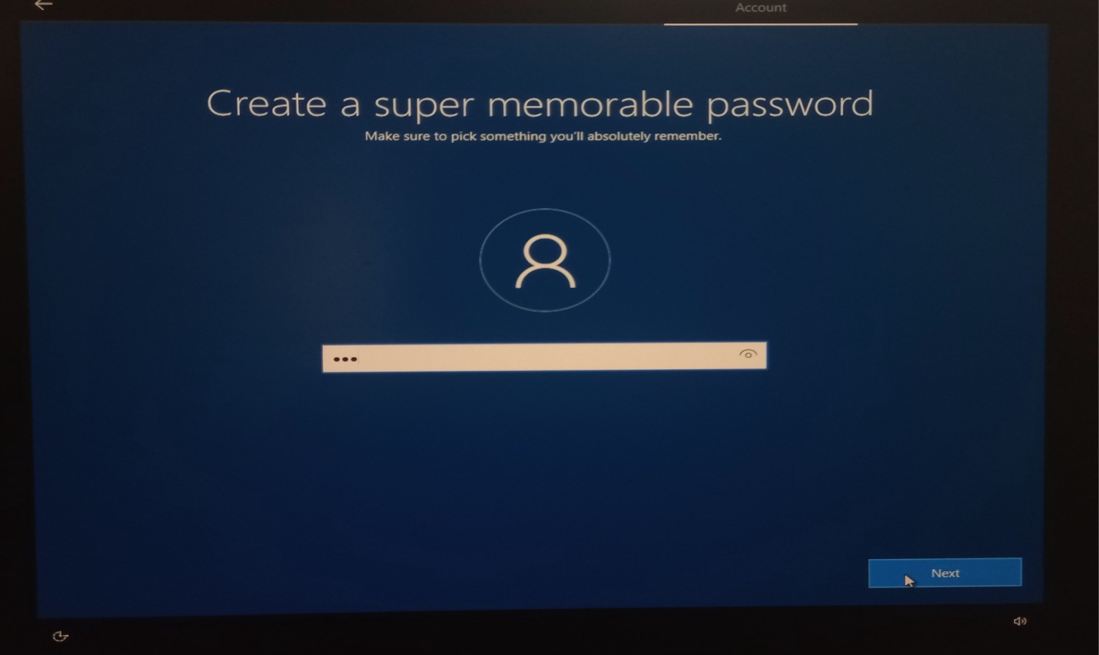

**Step 12**: Choose privacy settings for your device.

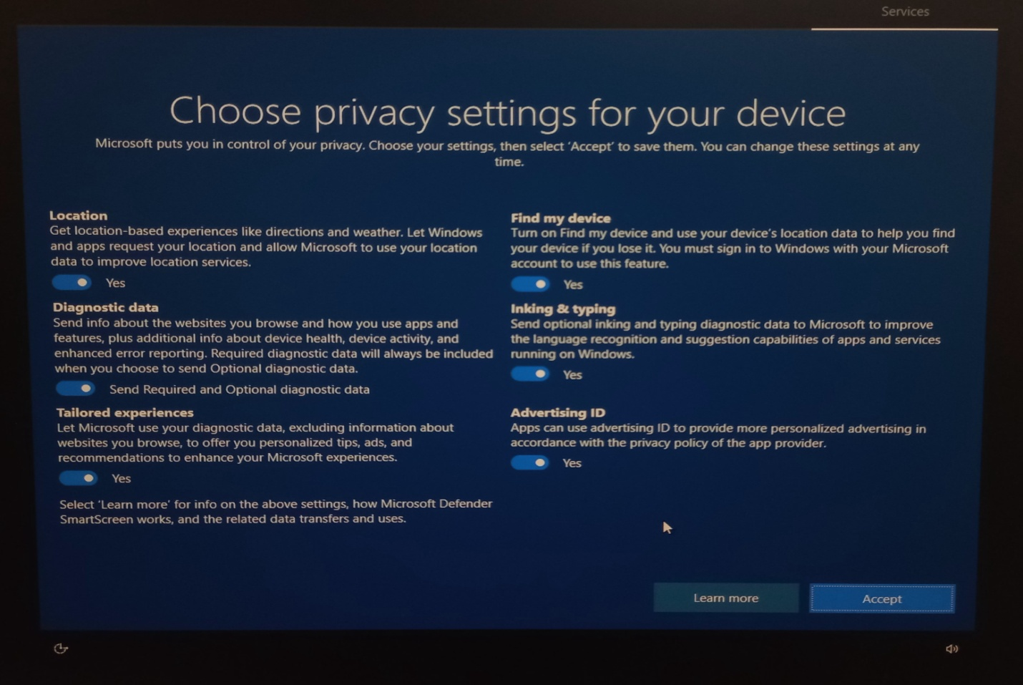

Step 13: Give some security questions’ answers.

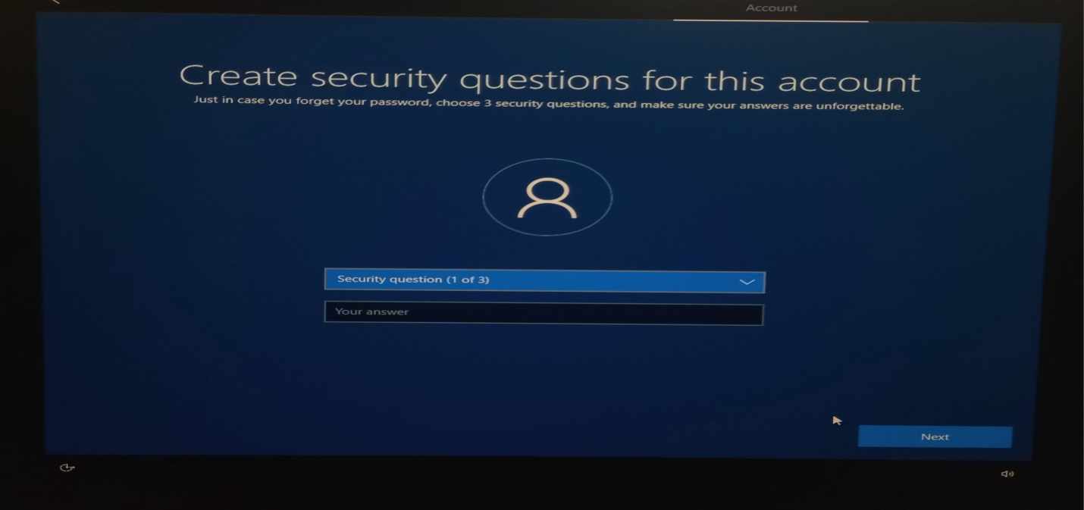

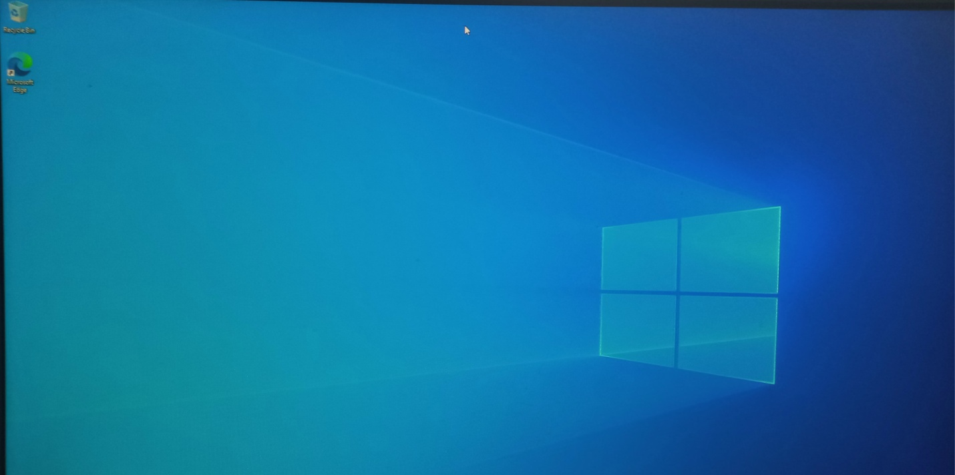

Your pc is ready. Here you go.Thank You.